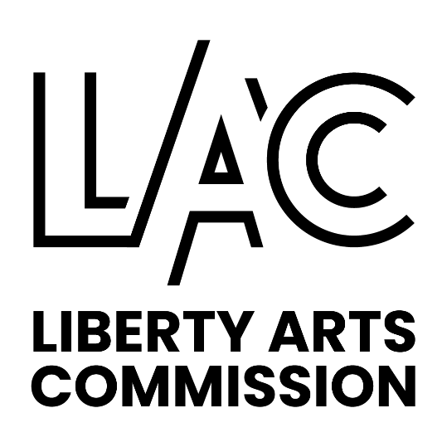

LIBERTY ARTS COMMISSION

MEETING SUMMARY

August 10, 2023

6:00 p.m. Admin Conference Room

Present: Garrett Brown, Greg Duncan, Molly Hon, Shane Immelt, Anna Knackstedt, Katie McDonald, Karly Schieder, Bill Stilfield, Nathan Wyman

Absent: Brian Kelley, Kelley Wrenn Pozel

Staff Present: Jeanine Thill, Community Development Manager

Guest: Jane Boswell, Clay Countians for Inclusion

The meeting was called to order at 6:02 pm by Chairwoman McDonald.

Commissioner Immelt made a motion to approve the July 13, 2023 meeting summary as presented. The motion was seconded by Commissioner Wyman. The motion passed 9-0-0.

Current Business

- Chairwoman McDonald reported that Kelley Wrenn Pozel is our new Council liaison. An orientation took place last week.

Mini Grant Application

Heartland Men’s Chorus Performance
- Chairwoman McDonald said the short write up is in the packet from the applicants clarifying how the marketing will be done for the event.
- Commissioner Duncan asked who is speaking in the statement.
- Ms. Boswell replied it is Clay Countians for Inclusion (CCI). It is a statement that connects the Arts Commission’s support to the performance.
- Commissioner Duncan wanted to make sure that the public money is attached to the art event and not the educational event.
- Ms. Boswell said they didn’t mention anything about the meeting/ educational event and they will not put that in any of the advertisement, it will be by invitation only.
- Commissioner Duncan suggested that marketing could state “funding for the performance is funded in part by the Liberty Arts Commission”. Our requirements are that our logo is to be used. A general concert flyer will include the LAC logo.
- Commissioner Hon commented that she agreed that the application was well done.
- Commissioner Schieder commented that the Heartland Men’s Chorus has never performed in the Northland, it will be a great new opportunity for those that live here.

A motion was made by Vice Chair Knackstedt to approve a $1,000 mini grant for Clay County for Inclusion to fund the Heartland Men’s Chorus performance in Liberty. The motion was seconded by Commissioner Immelt. The motion passed 9-0-0.

Transient Guest Tax Budget

- Ms. Thill said that the Transient Guest Tax (TGT) committee will be meeting in the next month to consider projects and the 2024 budget requests.
- Claire Rodgers, staff member that manages the TGT budget, suggested that we consider requesting funds for new projects and also if any changes are needed with our current programs. There were several items she suggested that we discuss:

Gallery Space in the Atrium
- Staff asked how does the Commission want this space to look when the construction is finished?
- Ms. Thill clarified that the art hanging system that was there previously will be reinstalled and expanded.
- Commissioner Immelt asked if we could consider purchasing a mobile glass display case to show 3D art.
- Commissioner Stilfield said Johnson County Community College has nice displays.
- Commissioner Immelt asked if we are considering a large screen TV in the City Hall atrium for digital art presentations, to maybe have digital art on the screens when it’s not being used for other things.
- Staff will look into this.
- Vice Chair Knackstedt asked about the lighting.
- Ms. Thill will ask if that is part of the existing construction budget.
- Chairwomen McDonald asked about the presence of our logo in the gallery spaces. We should promote that and be a part of that conversation, maybe a plaque would be enough.
- Commissioner Brown will look into options for a logo plaque or signage and report back to the group. Having our logo on the sculpture signage would be nice.
- Staff will ask about the sculpture lighting to be installed.
- Perhaps the Commission should ask for $10,000 (in place of the new logo line item) to bring our new logo and brand to life.
- The Commission would like to have a place holder for this project.
- Commissioner Duncan commented that the creation of the new logo could be considered phase one.
- Staff will ask for a rendering of the atrium, showing the lighting.
- Commissioner Schieder suggested that we think about installing a rotating sculpture at Corbin Mill.
- Commissioner Immelt suggested that LAC host a contest, with a pre-determine outcome, utilizing grant money and artwork as a welcome to Liberty, maybe near a city gateway, with 2D concepts. Artists could submit sketches, similar to the utility wraps call for artists.
- Commissioner Schieder commented that she likes the public involvement aspect of this.
- Commissioner Duncan commented maybe we want a line item for prize money for a program for someone to create something, the line item could be “incentive/prize money for future projects”. This would be different than the grants. It could be almost something like the Parade of Hearts where there is a template for people to create something.

Grants
- Commissioner Hon commented that she feels that the grants are being utilized.

Promotional Advertising & Marketing
- Commissioner Schieder said it would be nice for LAC to have a presence at events such as Fall Fest or other community events such as at the Disc Golf event.
- Commissioner Duncan commented that LAC doesn’t have a marketing budget.
- Commissioner Duncan said maybe we can do unexpected things like an Arts Commission basket at events. We need to think bigger than downtown. We could provide things / giveaways to support other people’s events so we have a presence. Maybe it’s LAC hiring a musician at an event.
- Commissioner Brown said maybe we have a giveaway to encourage people to use hashtags or posting photos.
- Commissioner Stilfield asked about reinstating an arts and crafts event.
- Commissioner Duncan said Arts Squared was a lot of work and time/labor intensive. The Commission discussed how we might create more partnership opportunities. This maybe a way to expand the grant program.

Make Music Day (MMD)
- The MMD committee would like increase the marketing/advertising and promotion budget.
- Commissioner Stilfield said with the growth this year and significantly more performances this year, he would like to see us do more advertising in the Kansas City market.
- Commissioner Immelt suggested that we market throughout the year to musicians, maybe something every few months.
- Chairwoman McDonald said she thinks the branding should be high on our priority list, the group agreed.
- As for possible permanent City Hall pieces, the inside piece(s) should be higher priority than the outside permanent piece.

Public Art Exhibits line item
- Commissioner Wyman asked what that line item could be used for.
- Staff said that in the past it was to promote our exhibits, this year we are promoting the exhibits by having print ad’s in KC Studio Magazine ‘s Gallery Guide.
- Maybe we can do large versions of the LAC stickers of signage for the Liberty Gallery’s.
- Commission Brown will do some research on this and come to the group with ideas.
- Commissioner McDonald will talk to the Library about that idea.

Insurance line item
- Ms. Thill was asked to see if there is an annual premium that we will need to pay.
- We may want to reduce the line item “supplies for the sculptures”, since most of the pads are poured and can be used year after year.

Sculpture Park
- Commissioner Schieder suggested that we could consider a sculpture park for when we acquire enough permanent sculpture pieces. William Jewell had considered this.
- The Commission agreed that this can be on the September meeting agenda.

Art Partner Reports:

Arts Foundation - Commissioner Duncan reported that they have a meeting set and they will bring back specifics at a later date.

Library - Commissioner Wyman said for the Withers branch there will be an exhibit on the 28th of Nano Nore. Drawings and Paintings of Rush Creek. There will be 20 pieces. The next Arts Commission Meeting might be at the Library.

Corbin Theatre - Commissioner Stilfield reported that they are continually growing audiences. Georgia Barge and Patrick Seely had a sell-out performance, twice recently. Jazz at the Garrison 1st Monday of every month.

Liberty Public Schools - No report.

The meeting adjourned at 7:33pm

