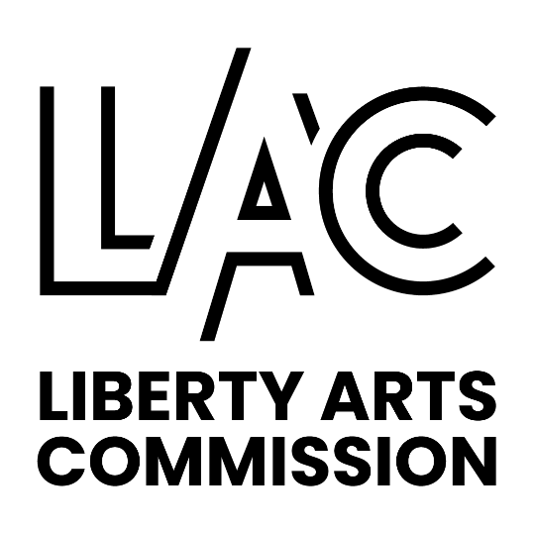

LIBERTY ARTS COMMISSION

MEETING SUMMARY

October 12, 2023

6:00 p.m. City Hall, Admin Conference Room

Present: Garrett Brown, Greg Duncan, Molly Hon, Shane Immelt, Brian Kelley, Anna Knackstedt, Kelley Wrenn Pozel, Katie McDonald, Karly Schieder, Nathan Wyman

Absent: Bill Stilfield

Staff Present: Katherine Sharp, Director of Planning & Development and Jeanine Thill, Community Development Manager

The meeting was called to order at 6:01 pm by Chairwoman McDonald.

Approval of Meeting Summary- Commissioner Immelt made a motion to approve the September, 2023 meeting summary as presented. The motion was seconded by Commissioner Brian Kelley. The motion passed 9-0-1. Commissioner Knackstedt abstained.

Current Business:

City Hall Art

Permanent Piece for Kansas Street Entrance-
- Staff reported that an HVAC Blower was found during the City Hall renovations, another staff member has proposed to wrap it in vinyl artwork, designed by high school students, similar to the artwork on the utility boxes, and placed outside the Kansas Street entrance as a permanent display.
- Staff reminded the group that the Art Acquisition and Selection Policy states that the Chair is to appoint a Selection Panel, if there is artwork that is proposed to be donated to or acquired by the City. Staff asked the group if that is something they would like to pursue.
- Commissioner Schieder likes the idea of upcycling.
- Commissioner Brian Kelley said he thought it was intriguing.
- Commissioner Knackstedt commented that it could be perceived as a trash can.
- Commissioner Hon wondered if it could be sealed off so people don’t mistake it for a waste receptacle.
- Commissioner Immelt asked if that was the quality of artwork we wanted at the entrance to City Hall.
- Commissioner Wyman said he doesn’t care for it at the proposed location. Maybe at another location. He added that the Kansas Street entrance location needs to have something that is very powerful. We might want to consider moving a piece that we already have to this location.
- Ms. Sharp said their role is to determine something is public art. The commission might want to do a Call for Artists to get proposals for a piece for that location.
- Chairwoman McDonald said she would not want to reach out to the school districts for artwork designs if we have no intention of doing this project.
- Commissioner Immelt said maybe we could have a specialized art program of recycling components. He is concerned that we are setting a precedent of selecting a piece that haven’t been juried in.
- Commissioner Schieder commented that an upcycled art show sounds interesting.
- Vice Chair Knackstedt asked if we could offer it to someone else. Maybe it could be an installation at the City Maintenance Building, although the maintenance building might not be were we want the public.
- Councilwoman Wrenn Pozel said maybe we could have it at the city building by Cody’s. The HVAC blower repurposed for art may not be our first choice for the entry way.
- Commissioner Brown commented that he loves the idea, but agrees that it might not be the best place. Also, he added that the vinyl wrapping works because there is more than one, such as the utility boxes, or the cows. But if there is just one on a recycled piece of equipment, people might not be as interested.
- Commissioner Duncan commented that an effort to improve the utility boxes creates an interesting series.

After discussing the Art Selection & Acquisition Policy, a motion was made by Vice Chair Knackstedt to not move forward with the proposal of the HVAC blower, repurposed as art, to be placed permanently on a pad outside of City Hall. The Commission will continue the process for considering pieces appropriate to that important location. The motion was seconded by Commissioner Immelt. The motion passed 10-0-0.

Update on mobiles for atrium
- The recommendation from LAC for the mobiles, by Jim Wolnosky, to be installed in the City Hall atrium was presented to the City Administrator and a few department heads. It was determined that we should live in the space for a while before the choosing art work for the atrium. As our policy states, we do have a process to follow with the Art Selection Panel.
- Commissioner Duncan said part of the “wow factor” is the unveiling of the atrium. If you hang something later, then it loses that.
- Ms. Sharp commented that is a design build approach, which is when somethings are a must, others are added in as they occur. She added that we don’t know what the cloud ceiling will look like. The wind was an issue in the atrium at one point and it isn’t cured with this project, that could be a factor too.
- Councilwoman Wrenn Pozel asked if there is an opening date. Ms. Sharp said there isn’t a set date. We are still months away.
- Chairwoman McDonald asked if it is related to the choice of the mobiles.
- Ms. Sharp said she thinks it is in part that that we don’t know what the ceiling will look like. She added that she doesn’t think that Curt would tell us what art to install. She feels like it would be a technical issue, such as wind, that would cause concern.

LAC Logo Signs
- Commissioner Brown talked about acrylic or translucent signage for galleries. He feels that the existing signs for the sculptures worked well.
- Commissioner Wyman said if we are pushing our new logo at the galleries then maybe the sign could be more substantial. Maybe a cutout metal.
- Chairwoman McDonald said at the Library a sign could be put out only when there is an artist that is connected to our group. Maybe it’s something on a stand. Signage for the galleries would be nice. Something that can be light weight and movable and another that is permanent.
- Commissioner Brown said he will look into ideas. We will discuss at the next LAC meeting.

Budget
- Ms. Thill reported that there are some funds left in the sculpture supplies and maintenance line item. We will discuss the budget balances at the next meeting and will see if it is an option to encumber the funds.
- Vice Chair Knackstedt said she would like to see us improve the signage for the permanent pieces, at Liberty Commons, etc. Maybe it could be cut sign that is more visible in the roundabout.

Other Business:

Recognition Committee Discussion-
- Commissioner Kelley asked that this be discussed and considered as a sub-committee of LAC. He explained that when he owned a pizza franchise and it is important how you treat and recognize people. He would like to have something to recognize others as it relates to the arts. Maybe it’s a plaque or a certificate. Anytime we can do something personal it can make a big difference in people’s lives. Most people are volunteering their time. Time is all we have. We should recognize those people. He would like to have a committee to recognize the people that make a difference.
- Chairwoman McDonald commented that this is an excellent reminder of who we want to be as a Commission.
- Commissioner Duncan suggested that we set up a task force or sub-committee that takes the lead and is accountable for recognition, chaired by Commissioner Kelley.

Consideration to establish a recognition sub-committee will be on the next agenda.

Art Partner Reports:

Liberty Arts Foundation (LAF) – Has been working on the basics of the Foundation. They have determined that there is a need to have a foundation. There are arts related causes that may not qualify for support by the LAC. The LAF is working on a revised mission. They are awarding grants, purchasing art work, maintaining and growing their general fund and working on collaborations with other artist groups. They hope to rebuild the Board. Also revamping their messaging.

William Jewell- Commissioner Wyman reported several performing arts things coming up. Wind ensemble will be Nov 1st and the Cardinalis Concert Nov 5th at Community Christian Church. A professional group that focus on performance and education. Nov 9-12 is The Inspector General, a 1950s movie. They have adapted the play to be set in the 1970’s sitcom.

Corbin Theatre- Commissioner Stilfield submitted the following written report:
Auditions for Little House on the Prairie – Musical are being held on October 7th & 8th 6:30 pm - 9:00 pm. The Corbin has another Community Event (free) called "Acoustic Night" which features 3 local acoustic artists on the Second Tuesday of each month from 6:00 to 8:00 pm. Murder on The Orient Express will be playing Oct. 19, 20, 21, 7:00 to 9:30 pm October 22 (matinee 2:00 - 4:30 pm) Tickets $15.00 per person

Liberty Public Schools- Commissioner Brown reported that Liberty high schools will be performing the Wizard of Oz and the Adams Family this fall. Aaron Money has revamped the fine arts website, it showcases the new programs this year. All the events are condensed into this website, to the fine arts page.

Due to several commissioners having schedule conflict the next LAC meeting will be on November 2, 2023 at 6 pm in the Administration Conference Room.

A motion was made by Commissioner Schieder to adjourn the meeting. The motion was seconded by Commissioner Wyman.

The meeting adjourned at approximately 7:19 p.m.

