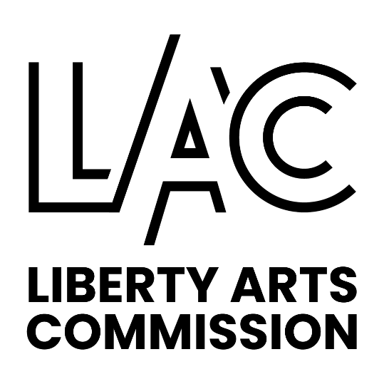

LIBERTY ARTS COMMISSION

MEETING SUMMARY

November 2, 2023

6:00 p.m. City Hall 3rd Floor Conference Room

Present: Garrett Brown, Greg Duncan, Molly Hon, Shane Immelt, Brian Kelley, Anna Knackstedt, Katie McDonald, Karly Schieder, Bill Stilfield

Absent: Kelley Wrenn Pozel, Nathan Wyman

Staff Present: Jeanine Thill, Community Development Manager

The meeting was called to order at 6:01 pm by Chairwoman McDonald.

Approval of Meeting Summary- Commissioner Brown made a motion to approve the October, 2023 meeting summary as presented. The motion was seconded by Commissioner Immelt. The motion passed 9-0-0.

Current Business:

2023 LAC Budget Balances
- Staff reported that we are not to spend the budget balance in the Insurance line item, but we can spend the remaining funds as allocated. The discussion tonight will be on how to best spend those funds before the end of the year. There is $16,698 remaining in the Sculptures /supplies line item, $798 in Make Music Day, $867 in Public Art Exhibits/Logo Redesign and $1,000 in Mini Grants and

Logo Signs Recommendation
- Commissioner Brown did some research and looked at some local businesses for signs that would be custom made with our logo, to be placed in the four galleries and at the rotating and permanent sculptures. He also spoke to Mike Jones at Personal Touch Engraving, who makes the existing sculpture signs, he said the existing signs are aluminum. He said they are $65 each they are 4x6, they are also available in up to 8X10. For the permanent signs, they might need a nicer sign that has longevity.
- Commissioner Duncan suggested that we budget for about $100 for each rotating $150 for each permanent and $200 for four gallery signs which totals about $3,800. We can use the $867 balance in Public Art Exhibits/Logo Redesign line item and $3,000 from the sculptures line item to get all of the signage taken care of.

A motion was made by Commissioner Duncan to allocate $3,800 for signage for the galleries, rotating sculptures and permanent sculptures. Combining the Logo Redesign and Public Art exhibit line items and the remainder to come out of the Sculpture line item. The motion was seconded by Commissioner Immelt. Motion passed 9-0-0.

- Commissioner Kelley commented that a recommendation to purchase the sculpture Dancing Figures was approved for purchase earlier this year by the selection panel.
- Commissioner Duncan said the only reason it wasn’t purchased was due to budget. It would be appropriate to purchase the piece and not have to reconvene the Selection Panel. It was in the 2023 budget and this is still the 2023. The placement is yet to be determined.
- Staff could take this to City Council for final approval in December.

A motion was made by Commissioner Kelley to purchase Dancing Figures for $9,000 and allocate $400 for the concrete pad or other expenses related to the installation. The motion was seconded by Commissioner Duncan. Discussion: The group agreed that the Selection Panel and the Commission liked Dancing Figures when they met in the Spring of this year and it was in the top three choices for purchase. The only reason we didn’t purchase it at that time was due to limited funding. It will determine later where it will be permanently placed. The motion passed 9-0-0. Leaving $4358 in the sculptures line item budget.

Establishing a Recognition Sub-Committee

A motion was made by Commissioner Kelley to establish a recognition sub-committee. The motion was seconded by Commissioner Immelt. The motion passed 9-0-0.

A motion was made by Commissioner Duncan to have Commissioner Kelley as the chair of the recognition sub-committee. The motion was seconded by Commissioner Immelt. The motion passed 9-0-0.

- Staff said she asked Commissioner Kelley to come prepared to this meeting with a budget request and his ideas for recognition that they would like to do in the next year.
- He was thinking of a few things: A business card to give to people, a simple certificate and possibly some plaques. He suggested that we send do a thank you card for the holidays to people that have supported the arts in Liberty. He showed example cards by Mouth and Foot holiday cards, made by artist that benefit from the sales. Also, he would like us to have business cards that have a place to sign the card or write a thank you and certificates of appreciation.
- Vice Chair Knackstedt said she likes the idea of sending something that is hand written and maybe a mosaic of the different sculptures. It will be important to look at the brand guidelines for the new logo when developing these materials.
- Staff will work with our PR/Communications division on the ordering and design.
- Commissioner Stilfield commented that he likes that this will raise the profile of the Arts Commission.

A motion was made by Commissioner Brown to allocate $500 for the recognition sub-committee for cards and recognition materials. The motion was seconded by Commissioner Immelt. The group suggested using some images of our sculptures with our logo rather than a Christmas card, furthering the brand, it was suggested that it is blank inside so we can do a handwritten message. We are getting a recognition and furthering LAC’s brand. The motion passed 9-0-0.

After these expenditures there is a balance of $3,858 is anticipated from all line items. The balance could be used to purchase lighting for the sculptures.

Commissioner Duncan made a motion to spend the remaining balance (approx. $3,858) on lighting for the sculptures. The motion was seconded by Vice Chair Knackstedt. Motion passed 9-0-0.

Mini Grant Sub Committee Recommendations
- Commissioner Hon recommended that because some of the rules require 60 days and the Annual Grants due in March, that cuts out 25% of the year, and we are missing out on opportunities for applicant to do projects January through March. By moving the deadline up to November or December, it would close that gap and allow the maximum amount of time for project to be done. There could be a disclaimer on it that it is pending funding approval in the new budget year. For the Annual Grant, it could be open in November or December of the prior year and due in January, so we might be able to vote on it at the January meeting. If we only have one application or no one applies, we can extend the application deadline.
- Chairwoman McDonald added that they are reimbursement grants, so we wouldn’t be spending money that isn’t allocated.
- Staff will make that change in the art grant applications to open them up in November or December.
- Mini Grants – Commissioner Hon said several of the mini grant applications have been very sparsely filled out and many times we have to ask more questions. She did some research on other cities art grant programs, including Lee’s Summit. She would be happy to draft something up to make our applications clearer. She may have an example application or tutorial for potential applicants.
- Commissioner Duncan added that maybe we can state that incomplete applications will not be considered.

Mini Grant Application
- A mini grant application was received from the Flamenco Dance Group, asking for funding to cover fees for students that couldn’t afford the fees, they would host rehearsals at a dance studio in Liberty and open them to the public. The final performance would be at the Woodneath Library, outside of Liberty.
- The Commission agreed that the final performance cannot be funded since it is outside of Liberty.
- Commissioner Stilfield said he has worked with the applicant and she has made a lot of headway since he worked with her adding that KC Studio wrote an article about her. He agrees that the Commission shouldn’t fund the final performance since it isn’t in Liberty.
- The Commission agreed that the timing of the rehearsals, in the middle of the week during the day, doesn’t make it very convenient to the general public. The grant funding is for the students that are coming from out of state.
- Commissioner Duncan commented that the hitch is we are paying for non-Liberty citizens, it seems that the use of the money is to benefit the students from out of state. It was suggested that they might be able to get a location at Liberty High School, the Library or at William Jewell.
- Also, per the grant requirements, funding is to be spend on programming in the current fiscal year, this is proposed it take place in June of next year.
- The Commission agreed that we should recommend that the applicant consider making some adjustments and reapply next year, if possible the final performance is preferred to be held in Liberty.
- Staff will relay this to the applicant.

Other Business:

Art Partner Reports:

Liberty Arts Foundation- Commissioner Duncan said the Foundation will be meeting soon

Library- No report

William Jewell- No report

Corbin Theatre- Commissioner Stilfield reported that Murder on the Orient Express was very successful. Next performance Wild Women of Winedale, on December 7th. Next Monday from 6-8 pm will be the last Jazz at the Garrison until March of next year. It is free, a seven-piece band.

Liberty Public Schools- Commissioner Brown reported the Wizard of Oz at Liberty North Wed 8-11th

Staff reported that due to construction at City Hall, if we have a December meeting, it will need to be via Zoom or at an alternate site. The group agreed that if we don’t have business to consider, we will cancel the December meeting.

Commissioner Stilfield and his band will be performing at B&B Theatre in Liberty on Dec 21st at Johnnies from 6:30-8:30. Several Commissioners said they will try to attend.

A motion was made by Commissioner Knackstedt to adjourn the meeting. The motion was seconded by Commissioner Brown.

The meeting adjourned at approximately 8:08 p.m.

